Problem Set #4

Geog 2000: Introduction to Geographic Statistics

Instructor: Dr. Paul C. Sutton
#1) Simple Linear Regression (Ordinary Least Squares) by Hand

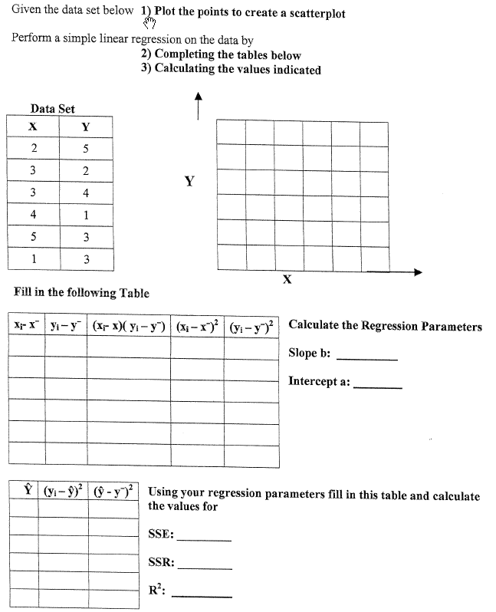

#2) Chi-Square (χ²) with Nominal and Spatial Data

For each problem:
- State a null and an alternative hypothesis;
- Define and calculate the value of a test statistic;
- Find the 95% Significance value for that test statistic (aka p = .05);
- Fail to reject or reject the Null Hypothesis.
- Provide a decision for the problem.

- A somewhat nutty person clams that blue-eyed people have a greater tendency to become avid Sailors (e.g. they own a sailboat). [They claim the Sea is reflected in their eyes]. Suppose you test this person’s ‘theory’ by randomly sampling 100 people.

Remember to:
- Remember to State your null and alternative hypotheses
- Define and calculate your test statistic
- Look up an appropriate value in a table to evaluate your hypothesis with 95% confidence
- Do you fail to reject or reject the Null Hypothesis
- State your conclusion in no uncertain Terms
- Earthquakes in California: Are they randomly distributed?
What you need to determine is if earthquakes are randomly distributed throughout the space of California?

Remember to:
- State your null and alternative hypotheses.
- Define and calculate a test statistic for this data.
- Look up the 95% critical value for your test statistic.
- Accept or Fail to Accept your Null Hypothesis
- Conclude something about the spatial distribution of earthquakes

- Winners of the Lottery: Are they randomly distributed? What you need to determine is if lottery winners are randomly distributed throughout the population of this metropolitan area. Test this hypothesis statistically.

Remember to:
- State your null and alternative hypotheses.
- Define and calculate a test statistic for this data.
- Look up the 95% critical value for your test statistic.
- Accept or Fail to Accept your Null Hypothesis
- Conclude something about the spatial distribution of lottery winners

#3) Match the scatterplot to a diagnostic and draw a residual diagram.

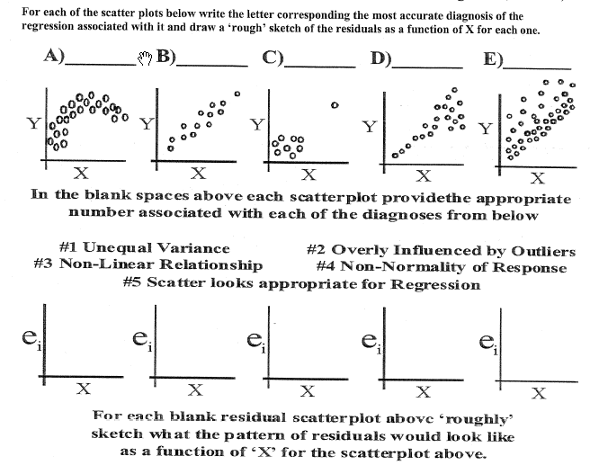

4) In Terms of Experimental Design….

A) Explain the ideas of Replication, Local Control, and Randomization as they pertain to Experimental Design.
B) Describe a rough design for the following experiments or research questions:

- The effect of consuming caffeine on short term memory

- Pain reliever effectiveness: What’s a better headache reliever – Advil or Excedrin

- Gender and Income: Who makes more money – Men or Women?

- SAT scores as a predictor of success in college.

- For each of the above four experiments or research designs describe issues will potentially confound and complicate your conclusions?
1)

2)

3)

4)

#5) How many statistical methods are there? More than we’ll ever know

We only touched briefly upon several other statistical methods. Google the following methods and provide a 3-5 sentence description of these approaches as to what they are used for and how they work
1) Logistic Regression

2) Cluster Analysis

3) Factor Analysis

4) Principle Components Analysis

5) Multivariate Regression

#6) Straight Up Linear Regression Problem (Use JMP))Do a linear regression on the ‘faked’ data below and tell me he value of the intercept and sleop for the best Ordinary Least Squares fit line through these data points.

- Show how you would calculate the slope, intercept and R²
- Calculate the predicted CSAP score of schools with 0%, 25%, 5-%, 75% and 100% of their students on free lunch programs
- Calculate the 95% Confidence Interval for the estimated or predicted CSAP score of a school with 50% of its students on the free lunch program
- Provide a one or two sentence interpretation of the results and comment on the potential ‘theoretical’ causality involved

The ‘a’ intercept:

The ‘b’ slope:

R²
Interpretation:

# 7) The Governor’s Interpretation….

When the former republican Governor of Colorado was presented with the relationship between CSAP scores and Free Lunch program participation that you characterized in the previous question (#6) he apocryphally said: “Oh, I get it. If we want to raise average CSAP scores we need to cancel the Free Lunch Program. Gee that’s great we actually spend less money to raise test scores.”

Comment on this statement with respect to your regression results. Is he right?

Metrics | Set I | Set II | Set III | Set IV
Mean X

Mean Y

Regression Line

Standard error of slope

t-value of slope

Sum of squares

Residual Sum of Squares

Correlation coefficient

R²

Scatter Plots:

Comments:

#9) Playing around with JMP’s Visualization Capability

Paste cool 3-d pictures here:

How can a three-dimensional visualization like this be akin to a remote sensing task of image classification?

Will pixels near each other in this visualization space necessarily be near each other in real space on the ground? Explain.

#10) It’s Book Report Time…

