Problem Set #4

Geog 2000: Introduction to Geographic Statistics

Instructor: Dr. Paul C. Sutton

Due Tuesday Week #9 in Lab
Instructions:
There are three parts to this problem set: 1) Do it by Hand Exercises (#’s 1 – 5). Do these with a calculator or by hand. Draw most of your figures by hand. Write out your answers either digitally or by hand. Start your answer to each numbered question on a new page. Make it easy for me to grade. 2) Computer exercises (#’s 6-9). Use the computer to generate the graphics and paste them into a digital version of this assignment while leaving room for you to digitally or hand write your responses if you so wish. 3) ‘How to Lie with Statistics’ Essay(s) (# 10). For this section, prepare a typed paragraph answering each question. Do not send me digital versions of your answers. I want paper copies because that is the easiest way for me to spill coffee on your assignments when I am grading them. You know the rules. Get Smart. Get going. This is a Shorter problem set. Nonetheless, Get started early – The Final Exam is looming.

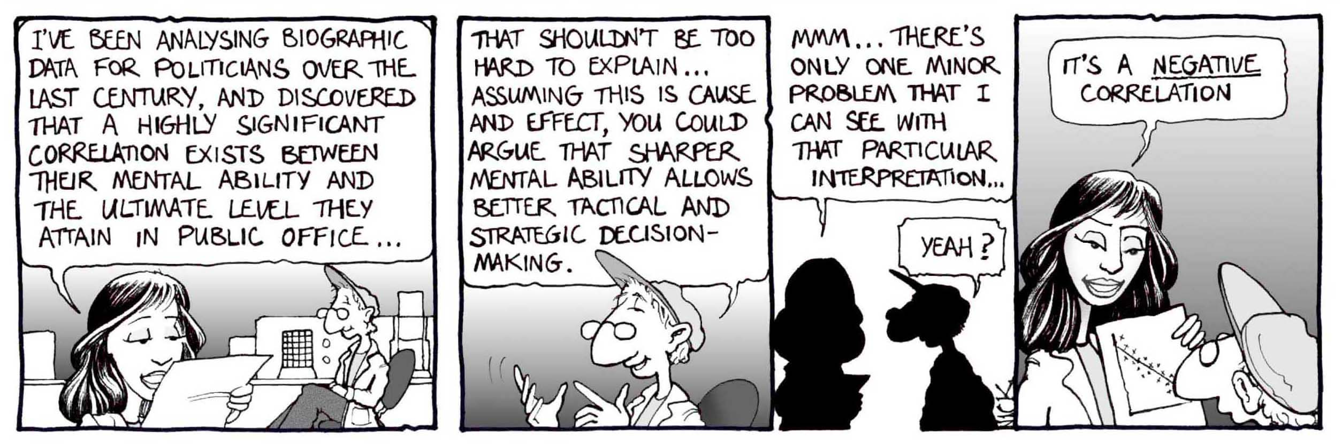

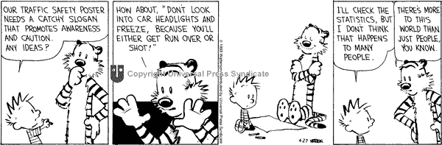

Politicians and People – Who really matters anyway?

Do it By Hand Exercises (i.e. Don’t Use A Computer)

#1) Simple Linear Regression (Ordinary Least Squares) by Hand

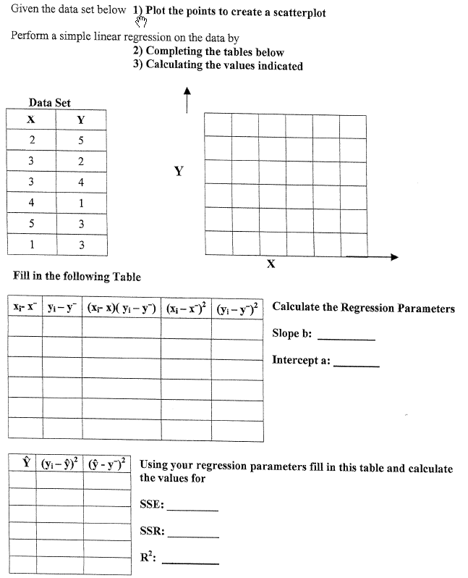

#2) Chi-Square (χ²) with Nominal and Spatial Data

For each problem state a null and an alternative hypothesis;
Define and calculate the value of a test statistic;
Find the 95% Significance value for that test statistic (aka p = .05);
Accept of Fail to accep the Null Hypothesis.
Provide a condlucind decision for the problem.

- A somewhat nutty person clamis that blue-eyed
People have a greater tendency to become avid Sailors (e.g. they own a sailboat). [They claim the Sea is reflected in their eyes]. Suppose you test This person’s ‘theory’ by randomly sampling 100 people. You measure their eye color and Whether or not they are a sailor. The table of Your results is listed to the right. Remember to State your null and alternative hypotheses toTest this person’s theory. Define and calculate Your test statistic. Look up an appropriate value In a table to evaluate your hypothesis with 95%
Eye-Color | Sailor | Non-Sailor
Blue | 3 | 27
Brown | 5 | 55
Other | 9 | 1
Confidence. State your conclusion in no uncertain Terms.

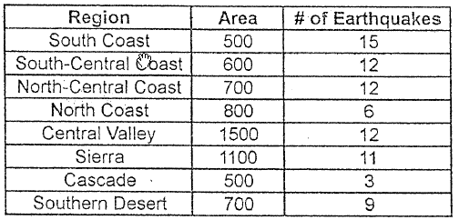
- Earthquakes in California: Are they randomly distributed?
At right is a roughly drawn map and an accurate table
Representing the map of 8 regions of California and the
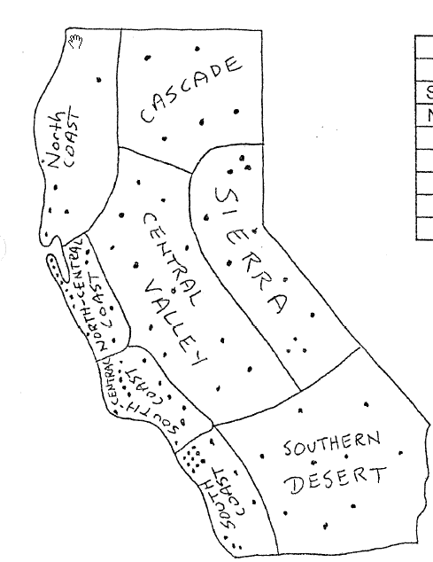
Location and number of earthquakes in those regions. What you need to determine is if earthquakes are randomly Distributed throughout the space of California. State your null and alternative hypotheses.Define and calculate a test statistic for this data. Look up the 95% Critical value for your test statistic. Accept or Fail to Accept your Null Hypothesis Conclude something about the spatial distribution of earthquakes.

- Winners of the Lottery: Are they randomly distributed?
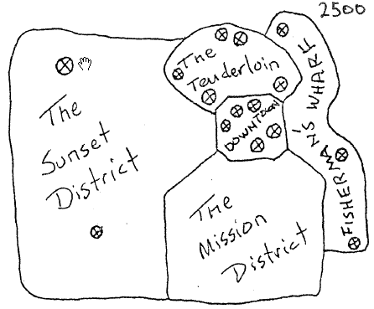
Below is a roughly drawn map of a hypothetical metropolitan area and an accurate table representing the census tracts and number of people who won the lottery. What you need to determine is if lottery winners are randomely distributed throughout the population of this metropolitan area. Test this hypothesis statistically.
State your null and alternative hypothesis.
Define and calculate a test statistic for this data.
Find the 95% critical value for your test statistic.
Accept or Fail to Accept your Null Hypothesis.
Conclude something about the spatial distribution
Of Lottery winners in this metro area.

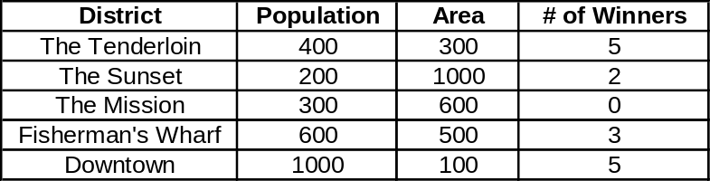

#3) Match the scatterplot to a diagnostic and draw a residual diagram.

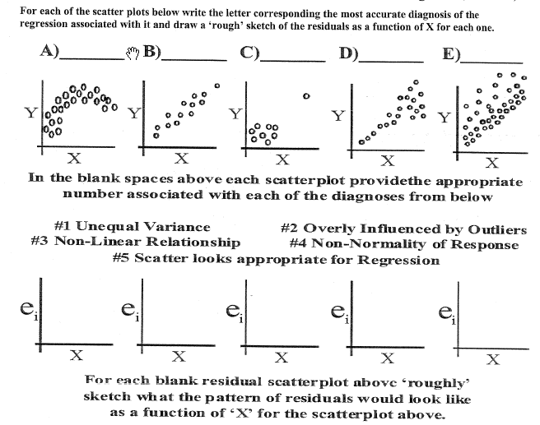
#4) In Terms of Experimental Design….

A) Explain the ideas of Replication, Local Control, and Randomization as they pertain to Experimental Design.

B) Describe a rough design for the following experiments or research questions:

- The effect of consuming caffeine on short term memory

- Pain reliever effectiveness: What’s a better headache reliever – Advil or Excedrin

- Gender and Income: Who makes more money – Men or Women?

- SAT scores as a predictor of success in college.

  - For each of the above four experiments or research designs describe issues will potentially confound and complicate your conclusions?

#5) How many statistical methods are there? More than we’ll ever know

We only touched briefly upon several other statistical methods. Google the following methods and provide a 3-5 sentence description of these approaches as to what they are used for and how they work:
1) Logistic Regression; 2) Cluster Analysis; 3) Factor Analysis; 4) Principle Components Analysis (PCA); 5) Multi-variate Regression;

Computer Problems (use JMP and/or Excel for these exercises)

#6) Straight Up Linear Regression Problem (Use JMP)

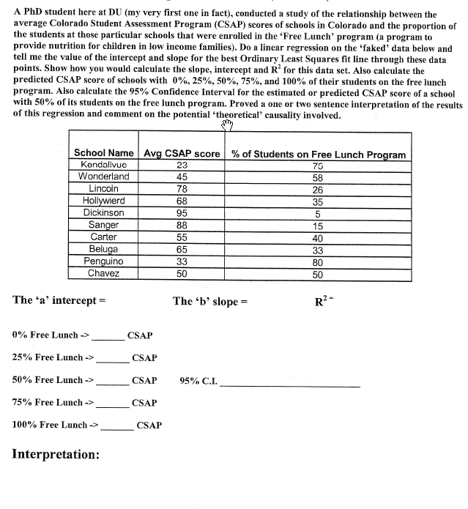

# 7) The Governor’s Interpretation….

When the former republican Governor of Colorado was presented with the relationship between CSAP scores and Free Lunch program participation that you characterized in the previous question (#6) he apochryphally said: “Oh, I get it. If we
want to raise average CSAP scores we need to cancel the Free Lunch Program. Gee that’s great we actually spend less money to raise test scores.” Comment on this statement with respect to your regression results. Is he right?

#8) Pattern Recognition, Scatterplots, and Linear Regression

Input all of these numbers into JMP as eight columns with 11 rows. Calculate the mean of X and mean of Y for each set (e.g. I, II, III, IV). Determine a regression line for each dataset. Calculate a standard error of estimate of slope for each dataset. Determine the t-value for each of these standard errors. Identify the sum of squares of (X-X-bar) for each. Identify the regression sum of square for each dataset. Identify the residual sum of squares for each dataset. Identify the correlation coefficient and R²s for each dataset. Look at the scatterplots and comment.

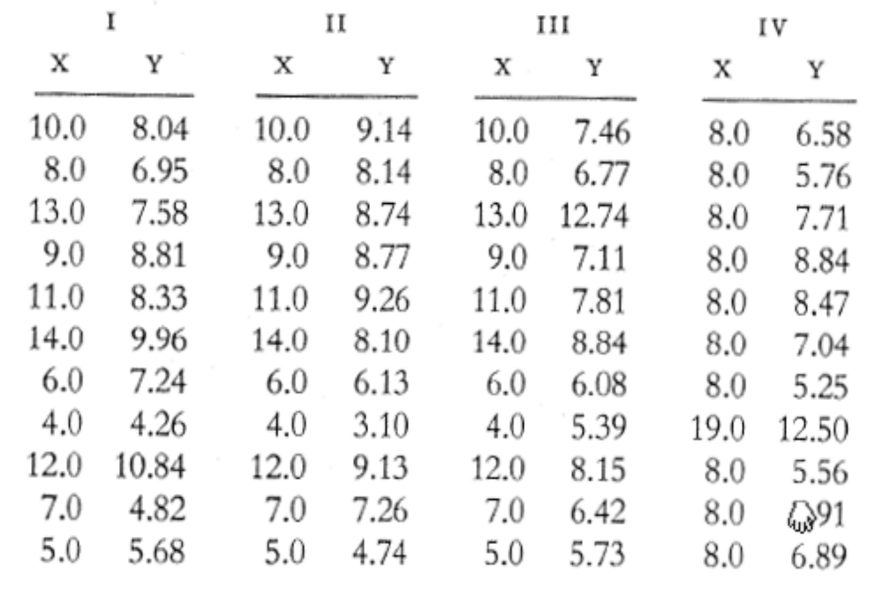

#9) Playing around with JMP’s Visualization Capability

Create a data table with 200 records in it. In one column create a N(100, 50), in a second create a N(50, 10), and in a third create a N(50, 5). Now go to ‘Graph’ -> ‘3-D Scatterplot’ and select all three of your columns as ‘y’ variables. Click and drag on the display. Create other columns and display rotated visualizations of the data.

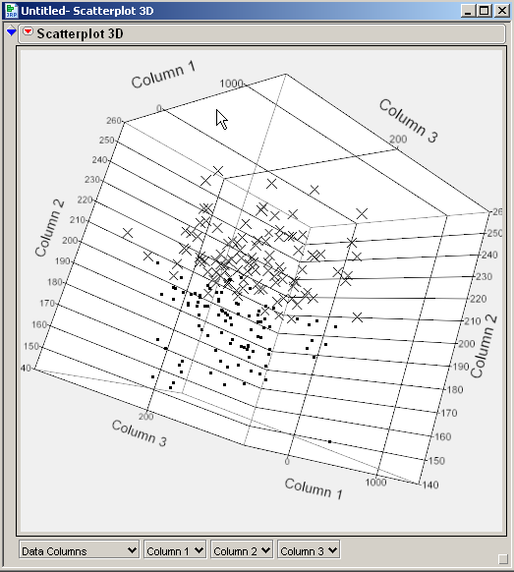

Play around with coloring and symbolizing the points based on various criteria. Also try to create three or more distinct clouds in your data visualization. Cut and paste two or more of your visualizations into your answer here.

How can a three-dimensional visualization like this be akin to a remote sensing task of image classification? Think of the three axes (x, y, and z) as the DN values of pixels in three bands of a satellite image or aerial photograph. Will pixels near each other in this visualization space necessarily be near each other in real space on the ground? Explain.

How to Lie With Statistics Question

#10) It’s Book Report Time…

Provide an overall summary of the book: How to lie with statistics by Darrell Huff. I am interested in your feedback as to ‘how well’ or ‘how not so well’ this book enhanced your understanding of the material we covered in this class. Should I continue to use this book as a supplement to the course? (5-10 sentences)

